Report for the lab 2

2.1. Task 01: CREATE Daily Reports Layouts

<https://github.com/nasekajlo/datamolacamp/tree/main/u2.lab1-3/lab%202>

2.2. Task 02: CREATE Monthly Reports Layouts

<https://github.com/nasekajlo/datamolacamp/tree/main/u2.lab1-3/lab%202>

3.1. Task 03: CREATE Test AdHoc SQL - Daily Reports (CUBE)

Cube. Daily pizza orders grouped by pizza_name and date

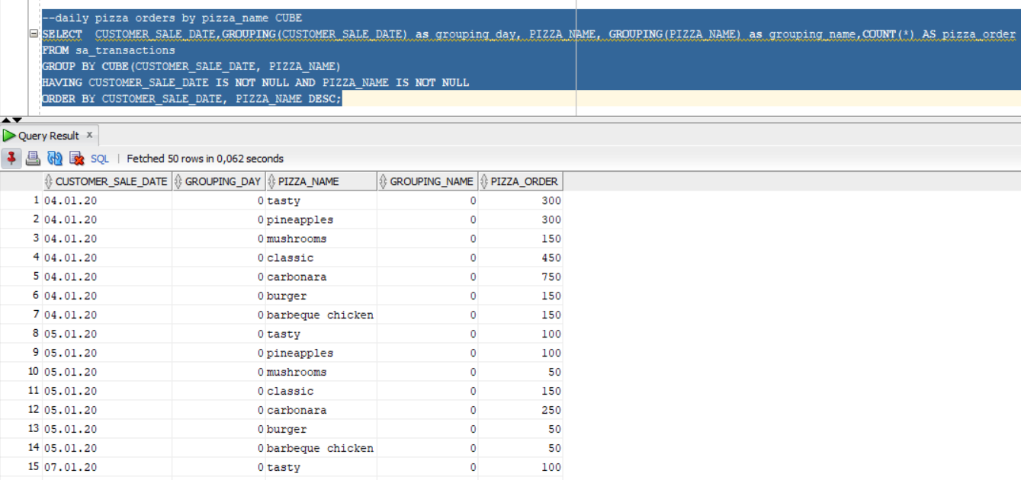

Cube. Daily pizza orders grouped by date and pizza size date 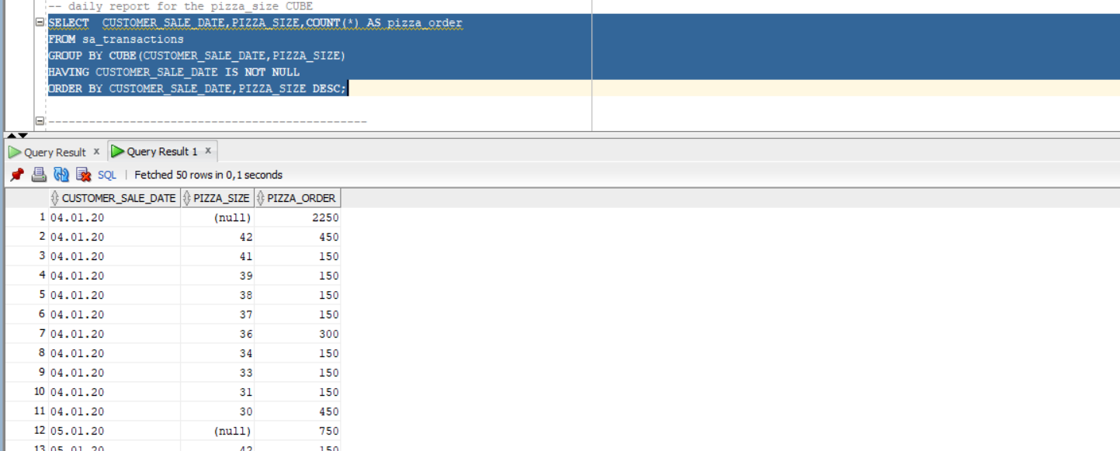

Cube. Daily pizza orders grouped by date and country and town

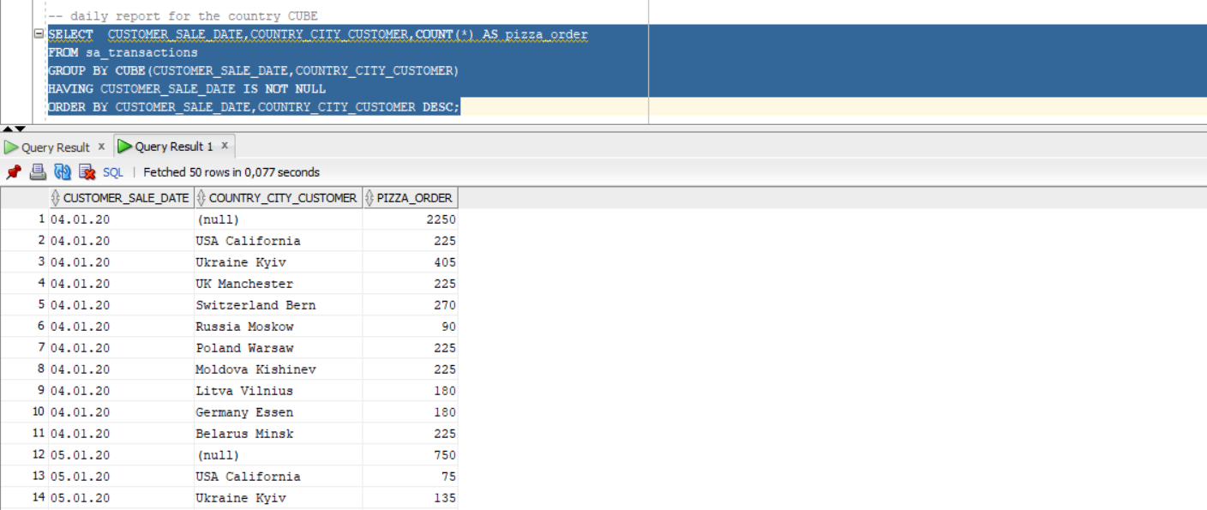

Task 04: CREATE Test AdHoc SQL - Monthly Reports (ROLLUP & GROUPING SETS)

Roll up:

Month pizza orders grouped by pizza_name

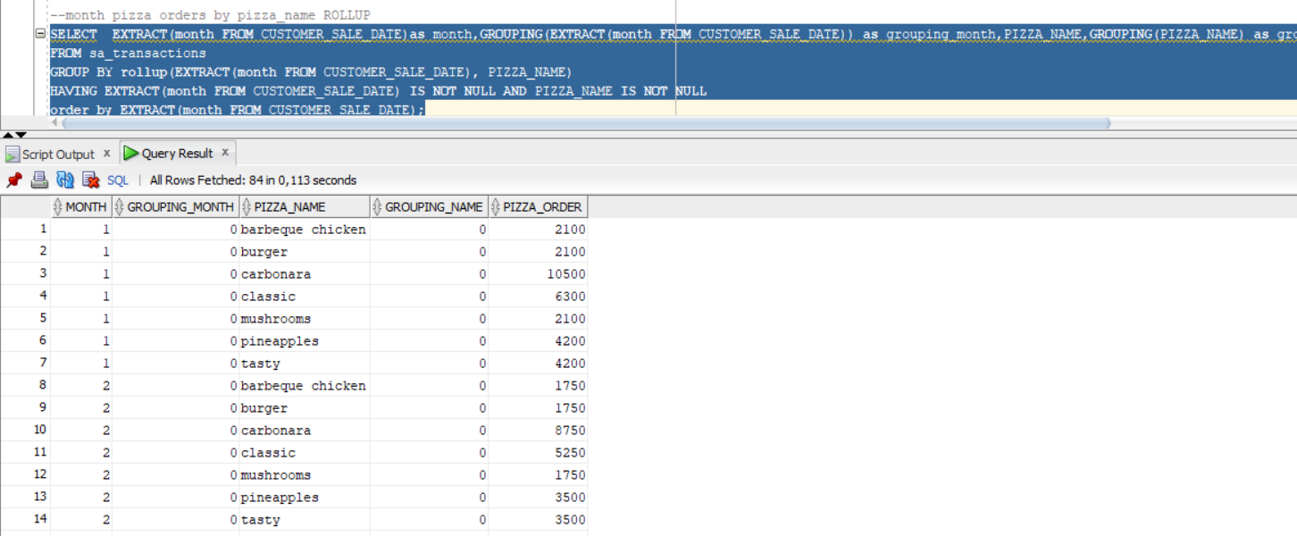

Month pizza orders grouped by date only (general orders)

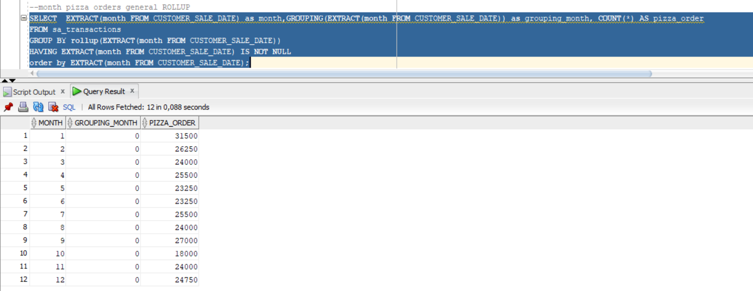

Grouping sets:

Month pizza orders grouped by month

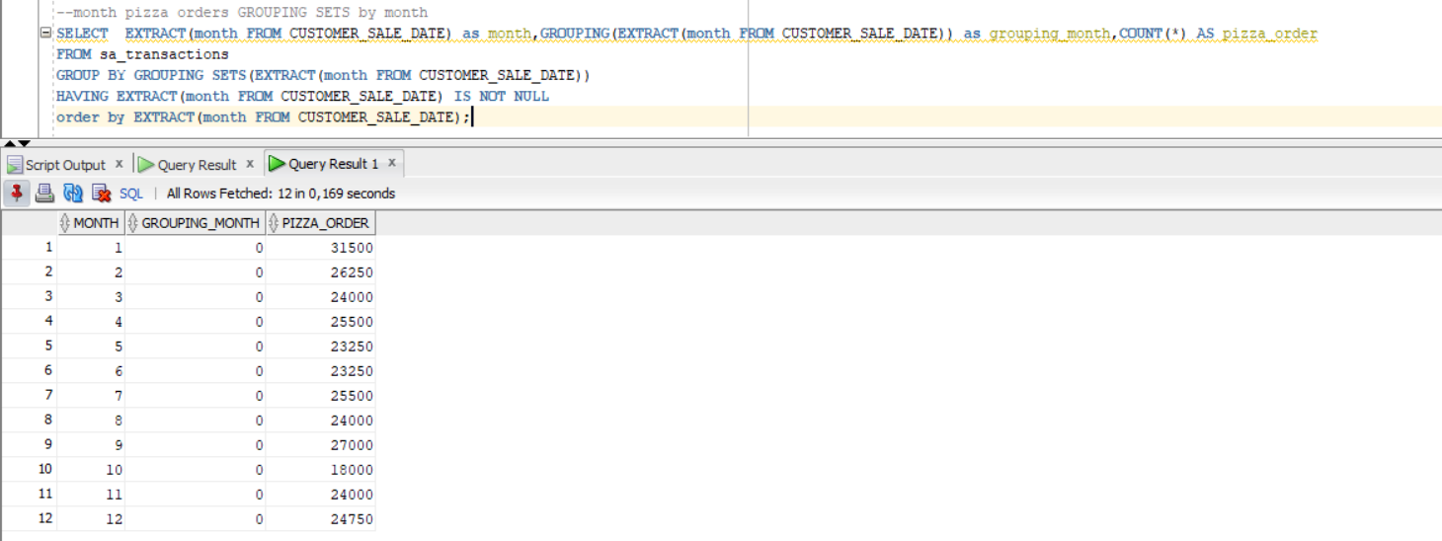

3.3. Task 05: CREATE Test AdHoc SQL – ROLLUP by Time

Day:

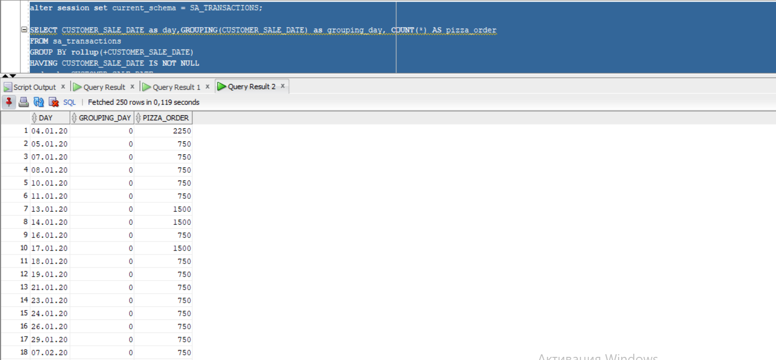Month:

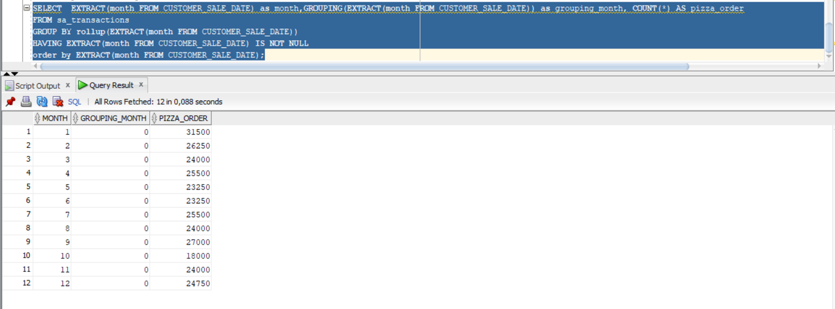

Year:

